EXPERIMENT – 10
K-MEANS CLUSTERING
Aim:
To perform model clustering using K-means Clustering technique
Procedure:
- Upload the given dataset
- Import all the necessities
- Read the dataset as DataFrame
- Using seaborn visualize the trends
- Using sklearn train the model for predicting

Program:
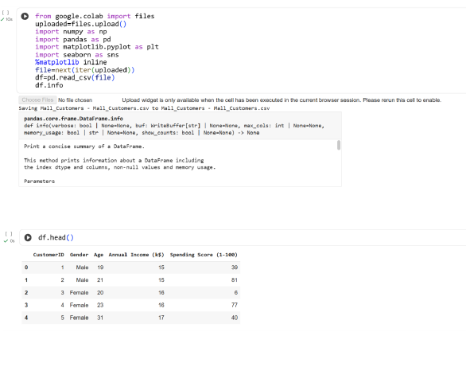

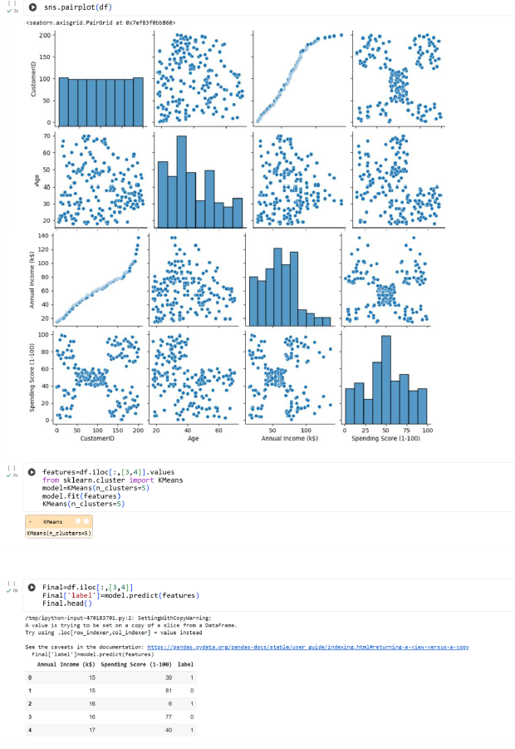

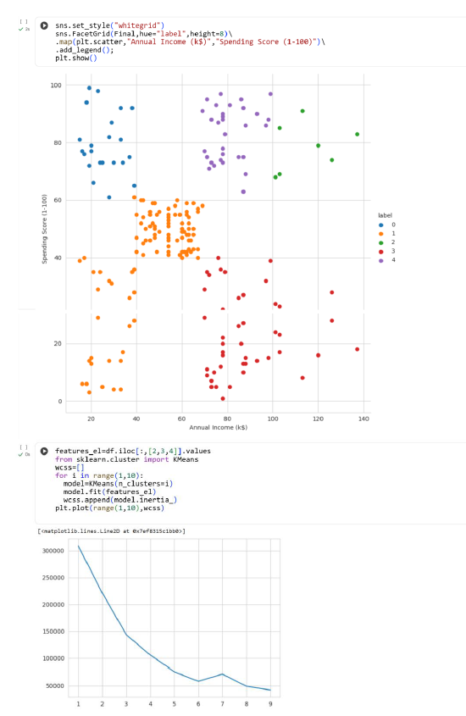
Result:
Thus the python program to make prediction model using K-means Clustering is executed and verified successfully

